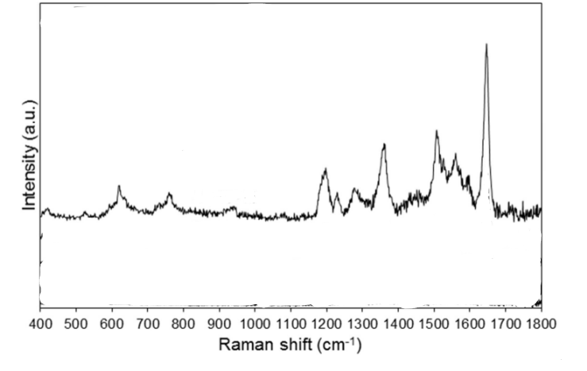

Figure 1:https://doi.org/10.1039/C5RA18806G

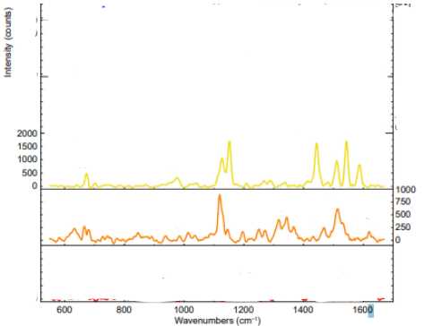

**Figure 2:**https://doi.org/10.29026/oea.2025.240309

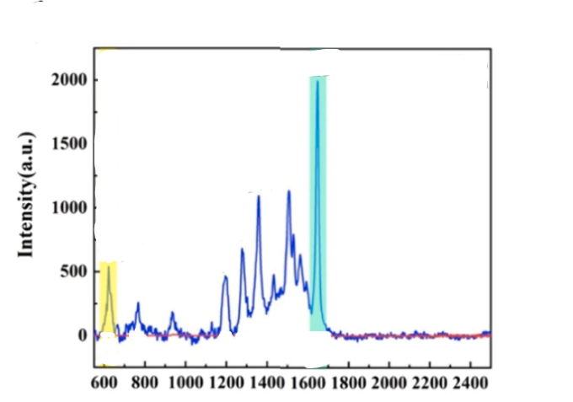

Figure 3:https://doi.org/10.1016/j.colsurfa.2022.130595

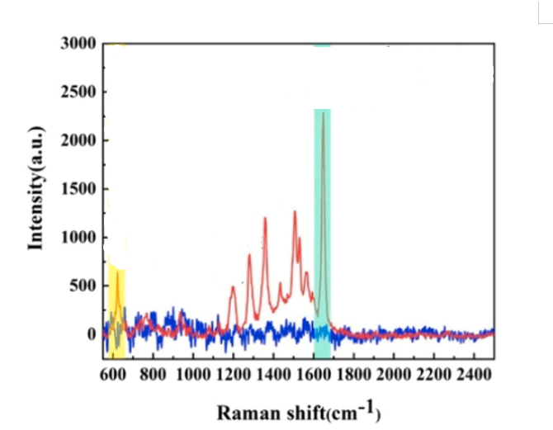

Figure 4:https://doi.org/10.1016/j.colsurfa.2022.130595

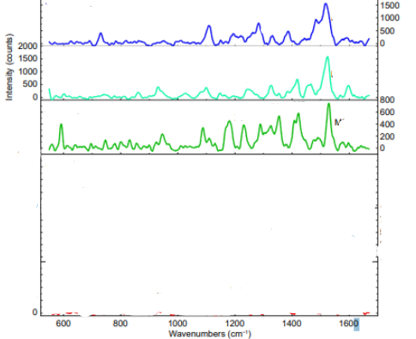

Figure 5:https://doi.org/10.29026/oea.2025.240309

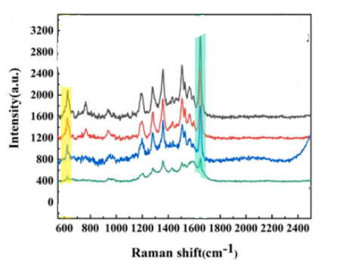

Figure 6:https://doi.org/10.1016/j.colsurfa.2022.130595

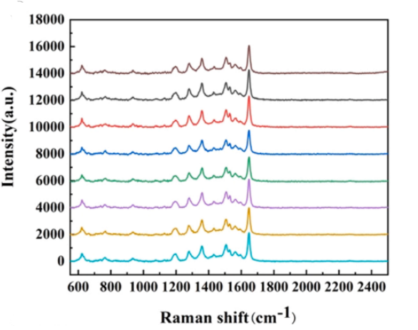

Figure 7:https://doi.org/10.1016/j.colsurfa.2022.130595

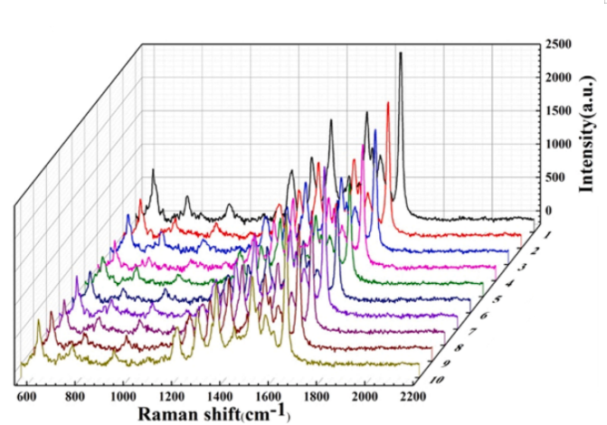

Figure 8:https://doi.org/10.1016/j.colsurfa.2022.130595

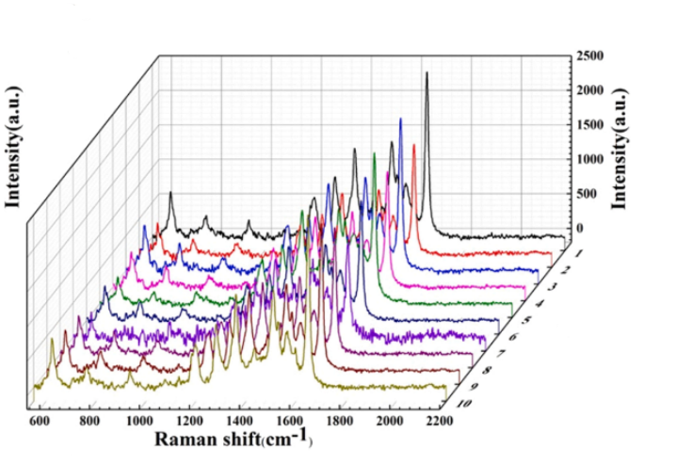

Figure 9:https://doi.org/10.1016/j.colsurfa.2022.130595

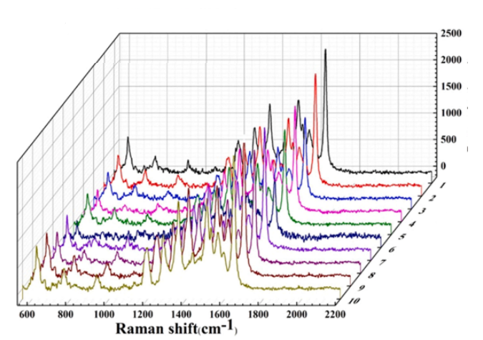

Figure 10:https://doi.org/10.1016/j.colsurfa.2022.130595

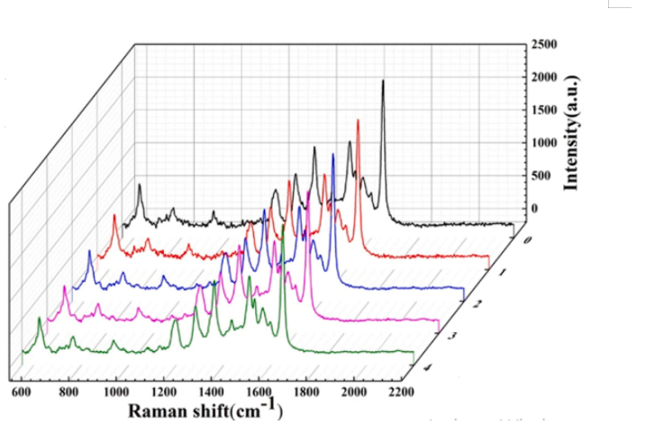

Figure 11:https://doi.org/10.1016/j.colsurfa.2022.130595

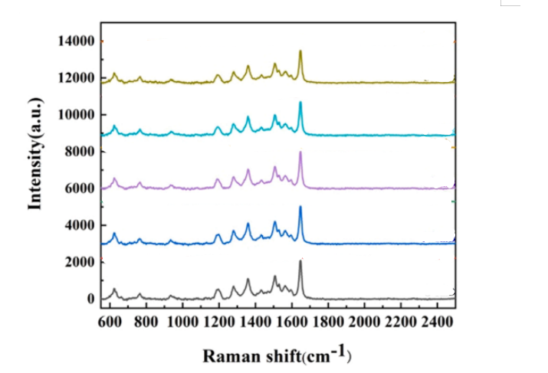

Figure 12:https://doi.org/10.1016/j.colsurfa.2022.130595

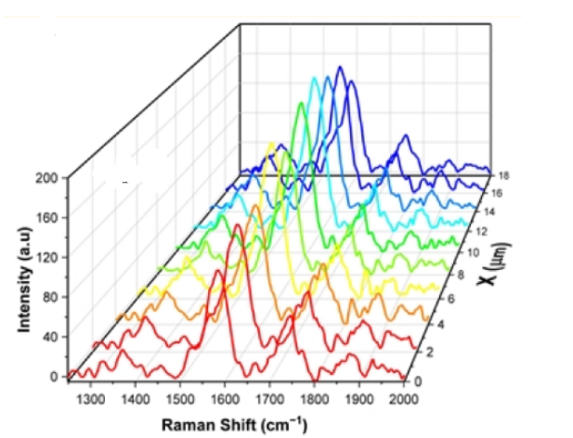

Figure 13:https://doi.org/10.3390/nano14181525

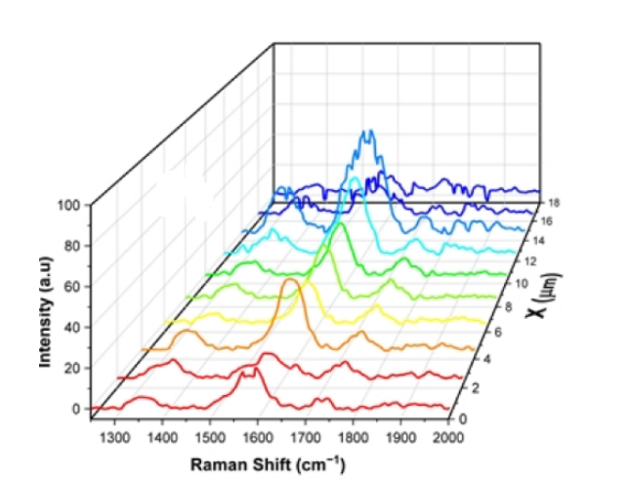

Figure 14:https://doi.org/10.3390/nano14181525

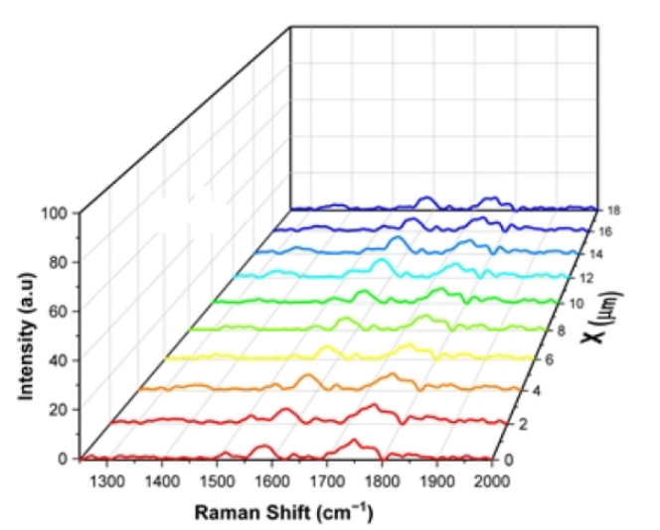

Figure 15:https://doi.org/10.3390/nano14181525

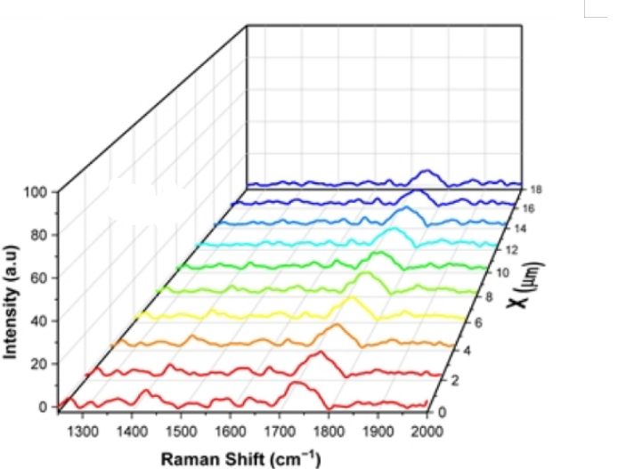

Figure 16:https://doi.org/10.3390/nano14181525

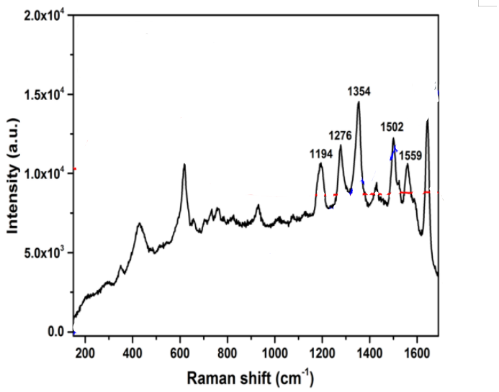

Figure 17:https://doi.org/10.1039/d5ma00040h

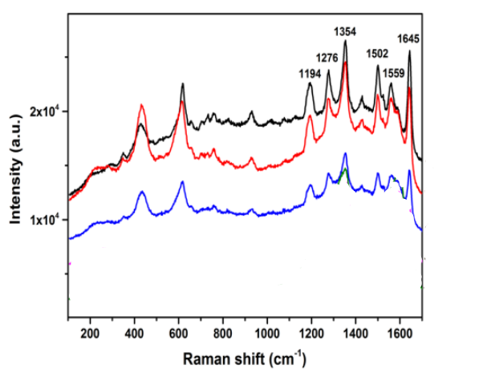

Figure 18:https://doi.org/10.1039/d5ma00040h

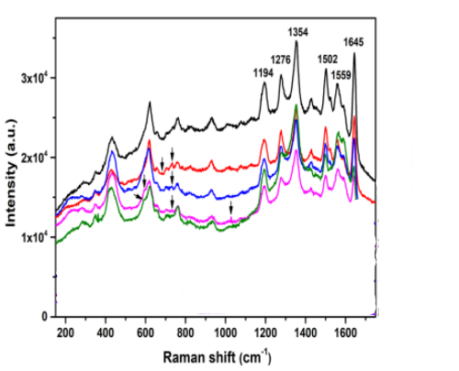

Figure 19:https://doi.org/10.1039/d5ma00040h

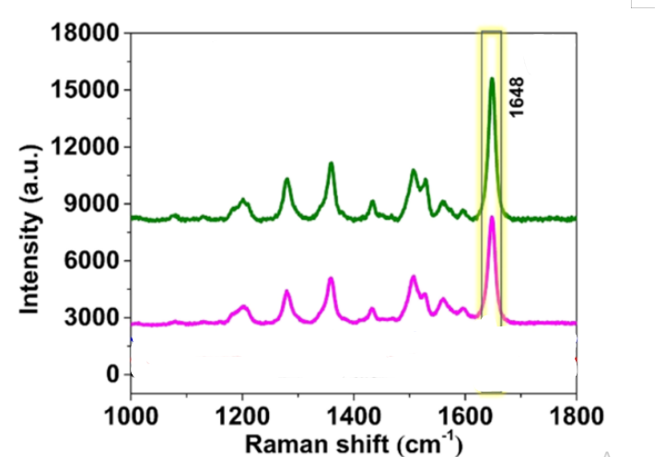

Figure 20:https://doi.org/10.1021/acsanm.3c00813

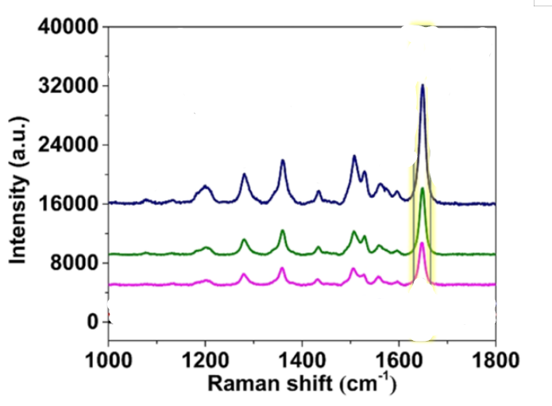

Figure 21:https://doi.org/10.1021/acsanm.3c00813

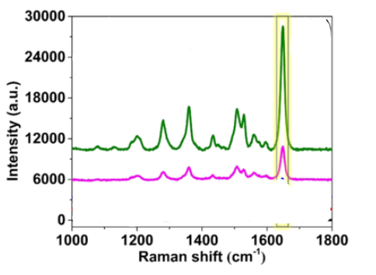

Figure 22:https://doi.org/10.1021/acsanm.3c00813

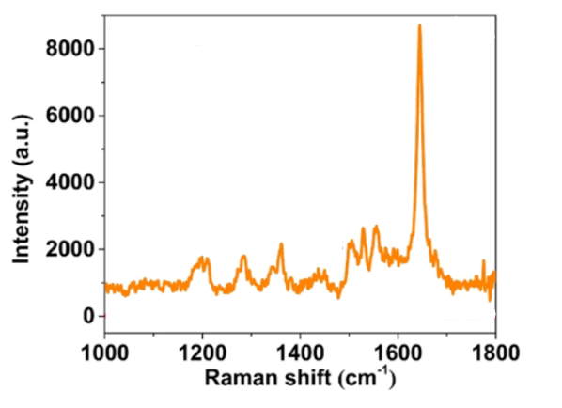

Figure 23:https://doi.org/10.1021/acsanm.3c00813

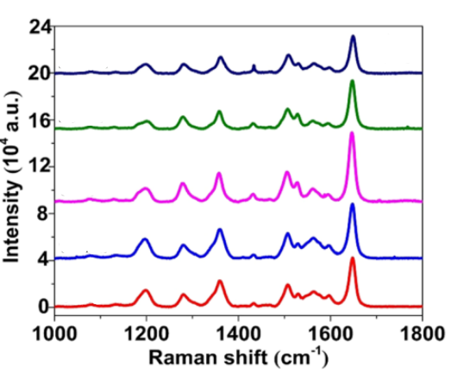

Figure 24:https://doi.org/10.1021/acsanm.3c00813

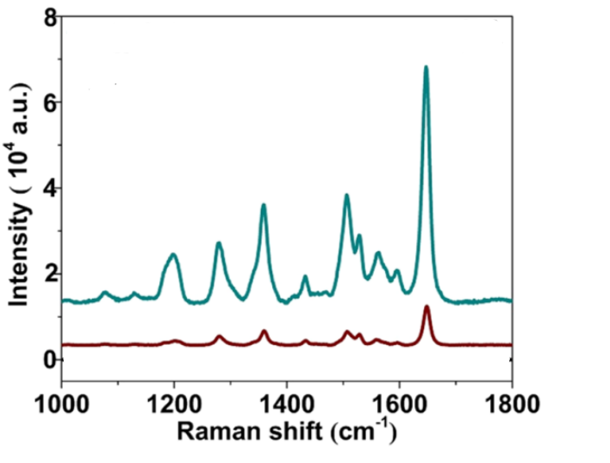

Figure 25:https://doi.org/10.1021/acsanm.3c00813

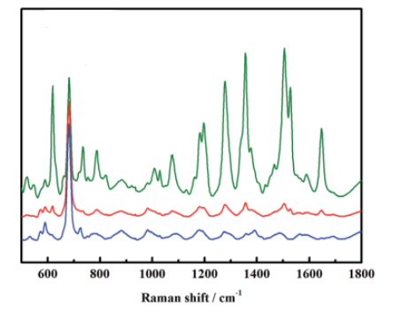

Figure 26:https://doi.org/10.1039/C4AY01487A

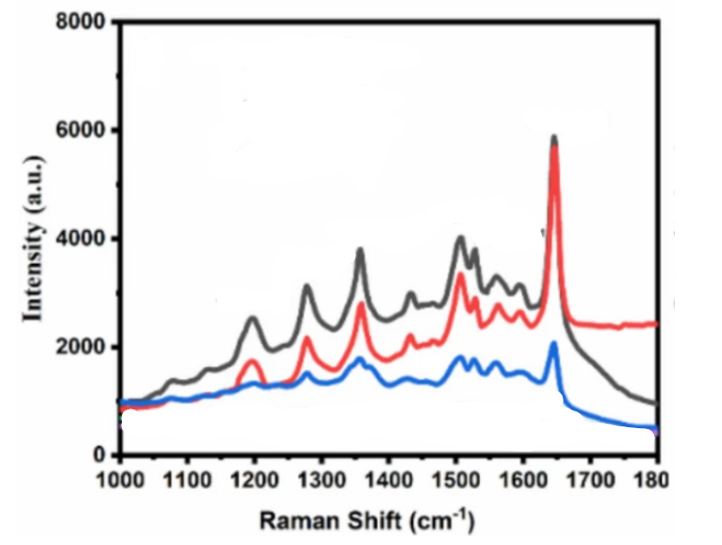

Figure 27:https://doi.org/10.1016/j.apsusc.2022.152696

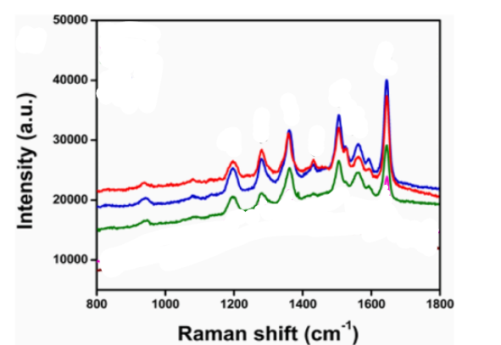

Figure 28:https://doi.org/10.1016/j.apsusc.2022.152696

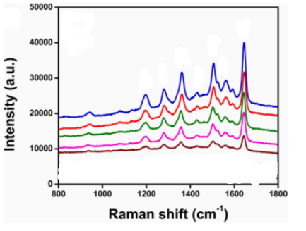

Figure 29:https://doi.org/10.1016/j.apsusc.2022.152696

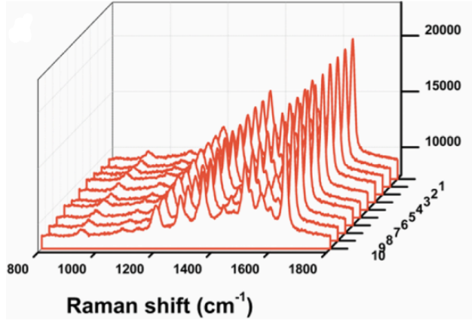

Figure 30:https://doi.org/10.1016/j.apsusc.2022.152696

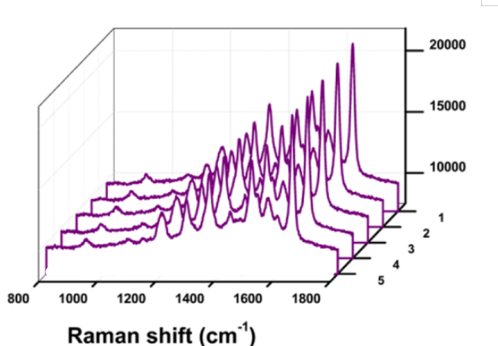

Figure 31:https://doi.org/10.1016/j.apsusc.2022.152696

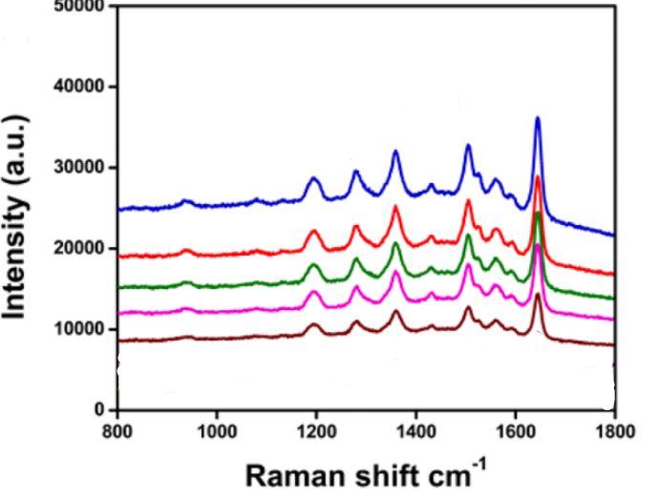

Figure 32:https://doi.org/10.1016/j.apsusc.2022.152696

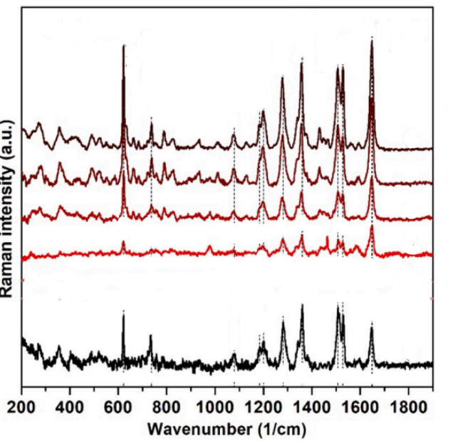

Figure 33:https://doi.org/10.1016/j.foodchem.2021.129741

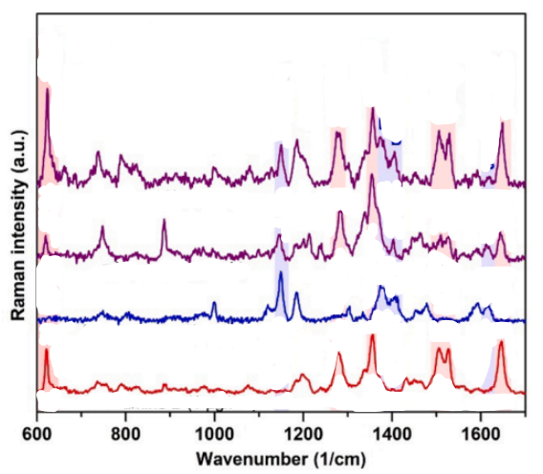

Figure 34:https://doi.org/10.1016/j.foodchem.2021.129741

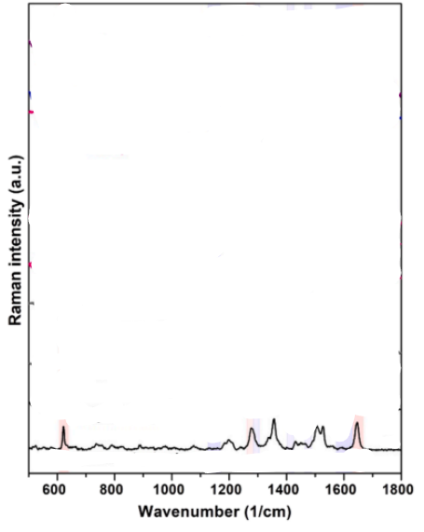

Figure 35:https://doi.org/10.1016/j.foodchem.2021.129741

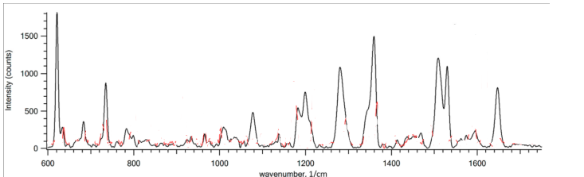

Figure 36:https://doi.org/10.3390/nano12030448

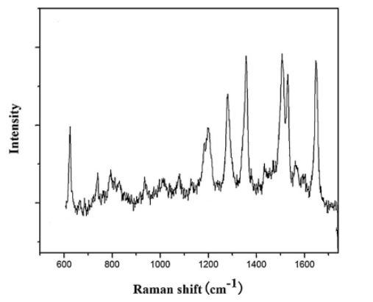

Figure 37:https://doi.org/10.1016/j.apsusc.2016.03.084

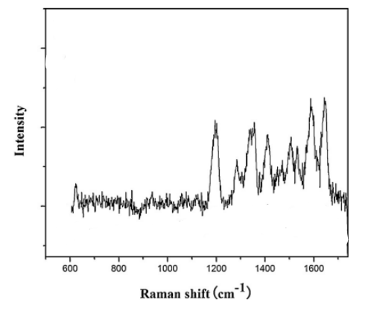

**Figure 38:https://doi.org/10.1016/j.apsusc.2016.03.084**

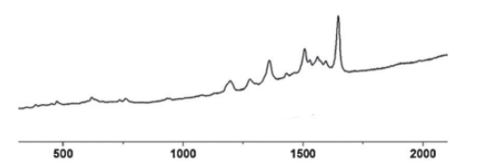

Figure 39:DOI: 10.1039/c1cc12072g

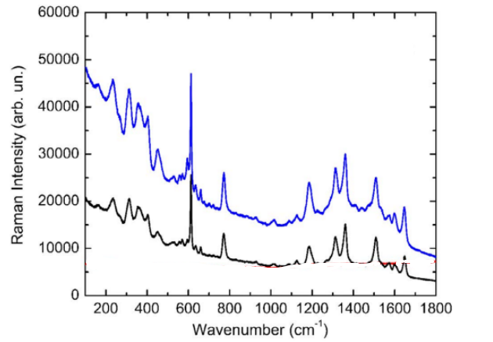

Figure 40:https://doi.org/10.1002/pssa.201900965

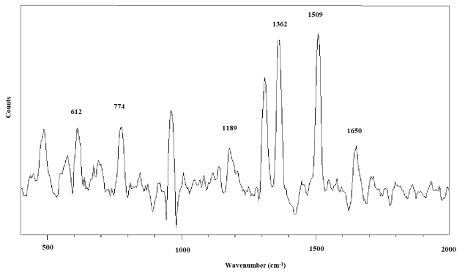

Figure 41:DOI: 10.18038/estubtda.1237440

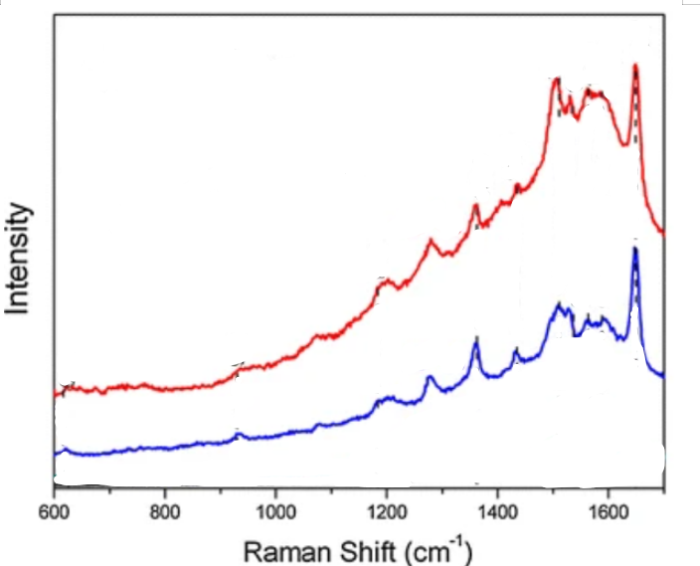

Figure 42:https://doi.org/10.1007/s11051-014-2470-7

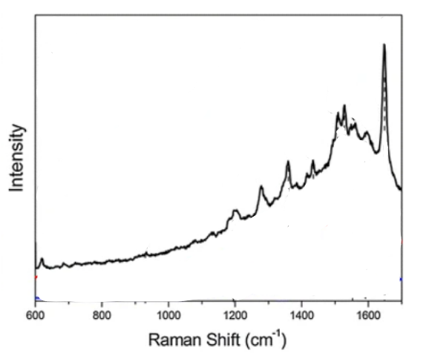

Figure 43:https://doi.org/10.1007/s11051-014-2470-7

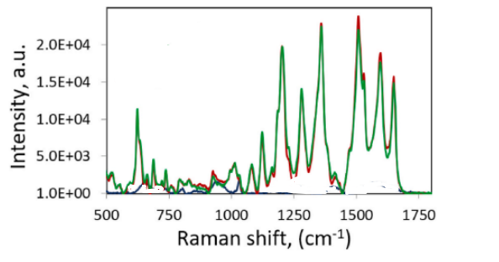

Figure 44:https://doi.org/10.1016/j.matchemphys.2022.126288

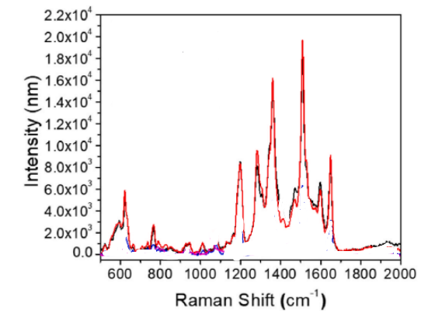

Figure 45:https://doi.org/10.1016/j.matchemphys.2022.126288

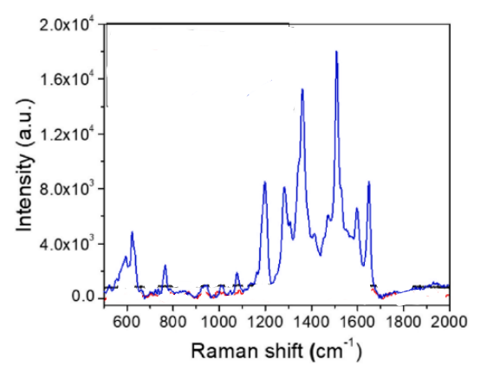

Figure 46:https://doi.org/10.1016/j.matchemphys.2022.126288

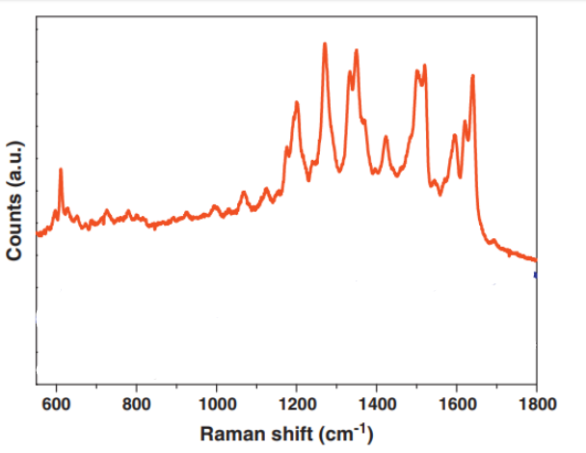

Figure 47:https://doi.org/10.1016/j.surfcoat.2012.06.084

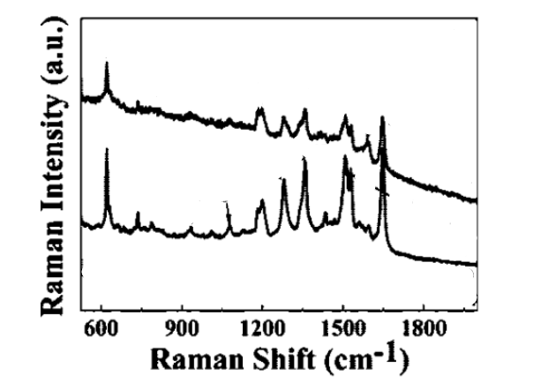

Figure 48:https://doi.org/10.1021/cm800882n

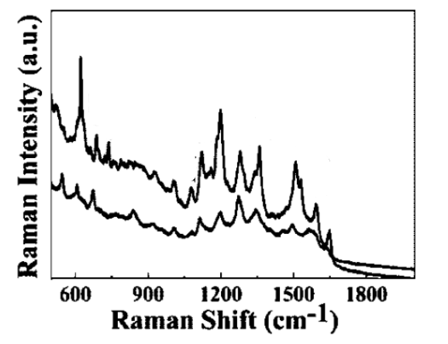

Figure 49:https://doi.org/10.1021/cm800882n

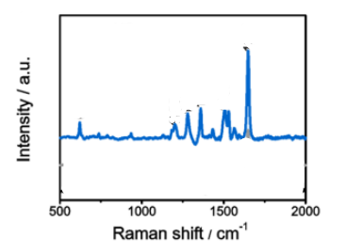

Figure 50:SERS spectra of 1 × 10−4 M RhB solution from Ag NCs, Ag NDs, and ITO

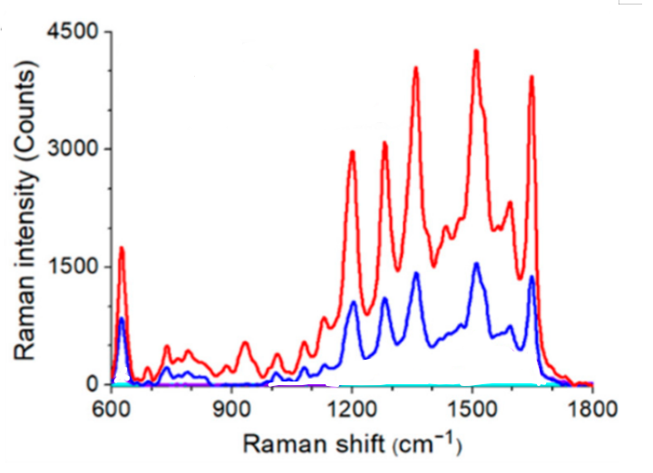

Figure 51:https://doi.org/10.3390/nano11071678

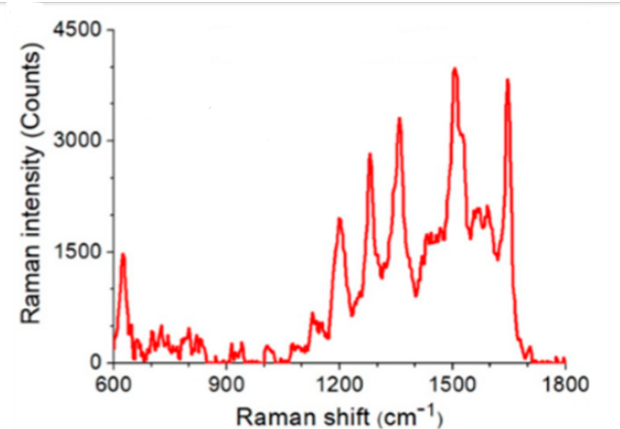

Figure 52:https://doi.org/10.3390/nano11071678

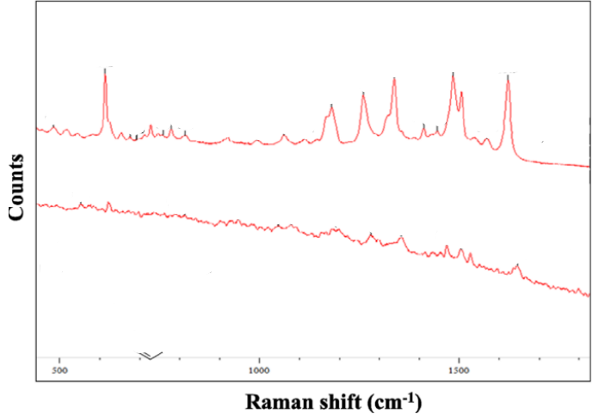

Figure 53:https://doi.org/10.1016/j.physe.2015.11.002

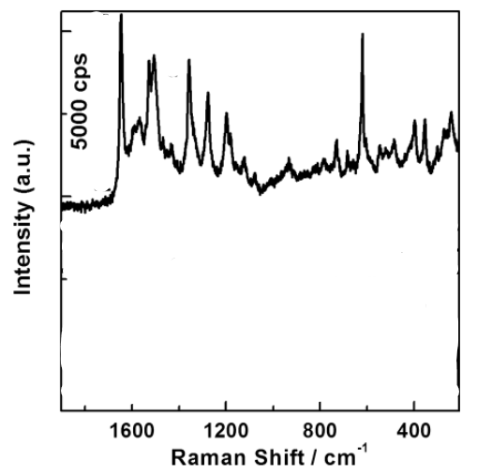

Figure 54:https://doi.org/10.1021/jp904046h

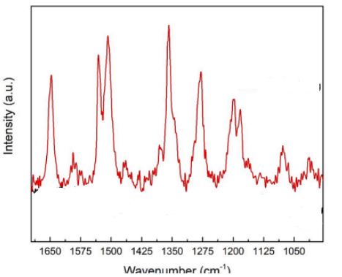

Figure 55:https://doi.org/10.1016/j.jcis.2024.05.181

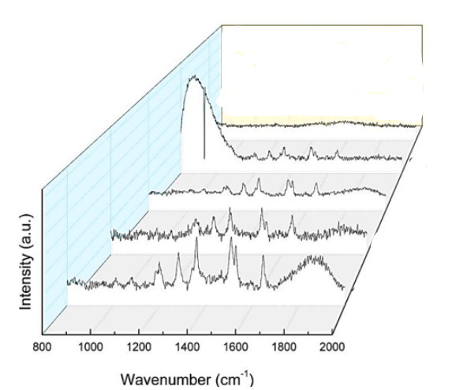

Figure 56:https://doi.org/10.1016/j.jcis.2024.05.181

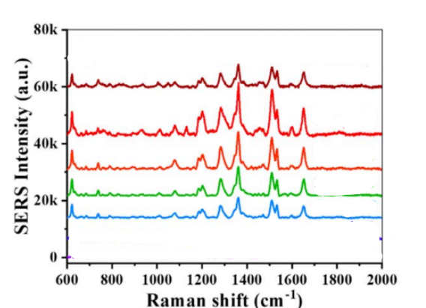

Figure 57:DOI 10.1088/1361-6528/ab2845

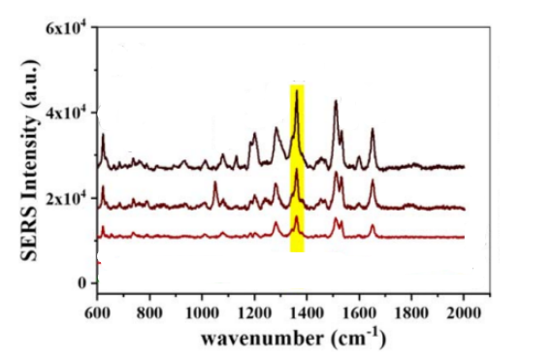

Figure 58:DOI 10.1088/1361-6528/ab2845

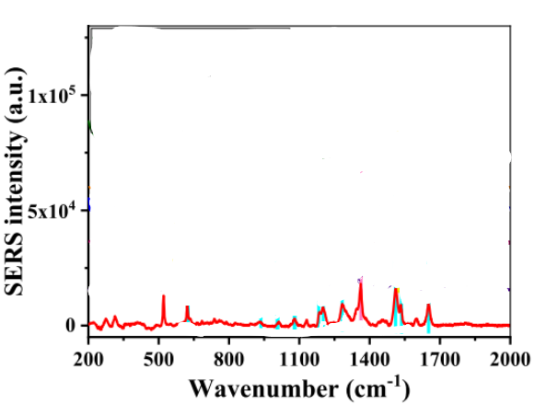

Figure 59:DOI 10.1088/1361-6528/ab2845

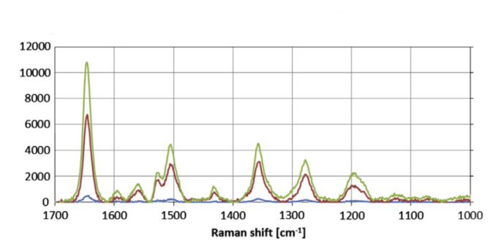

Figure 60:https://doi.org/10.1016/j.jelechem.2014.10.012

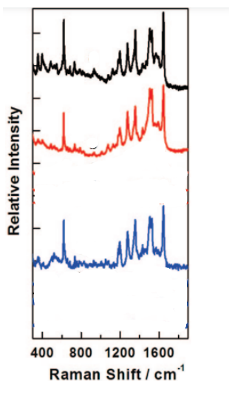

Figure 61:https://doi.org/10.1177/2280800017753055

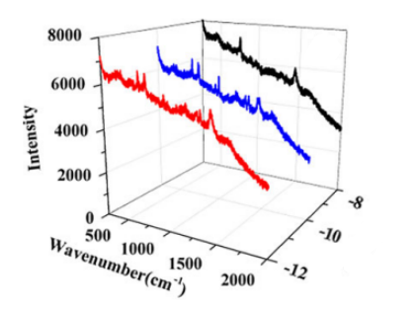

Figure 62:https://doi.org/10.1002/aoc.4791

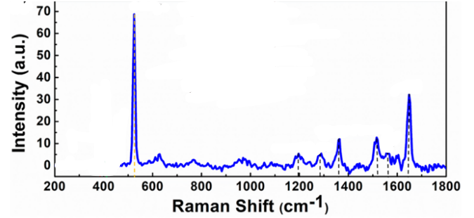

Figure 63:https://doi.org/10.1021/ac400240v

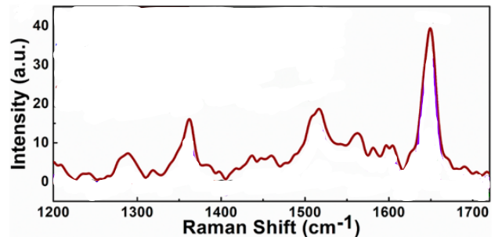

Figure 64:https://doi.org/10.1021/ac400240v

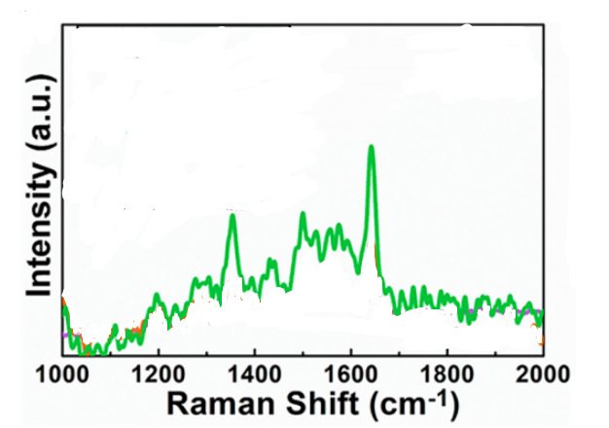

Figure 65:https://doi.org/10.1021/ac400240v

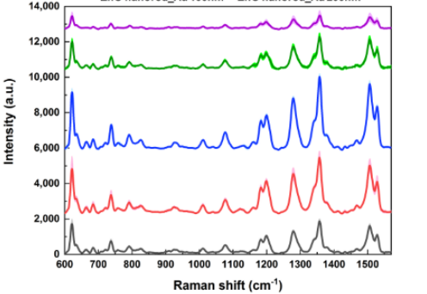

Figure 66:https://doi.org/10.3390/nano9030447

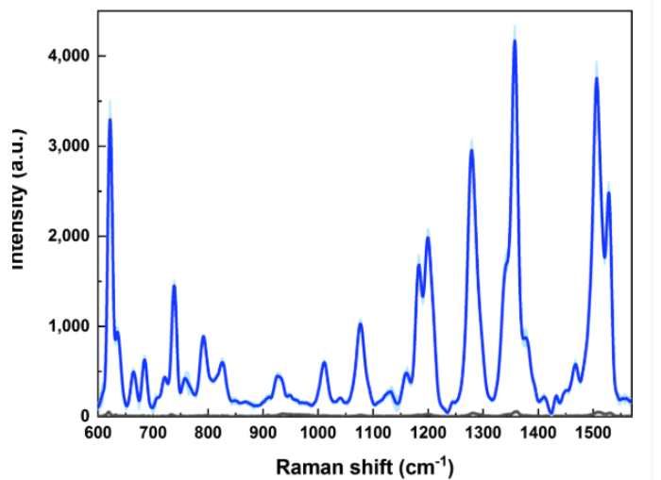

Figure 67:https://doi.org/10.3390/nano9030447

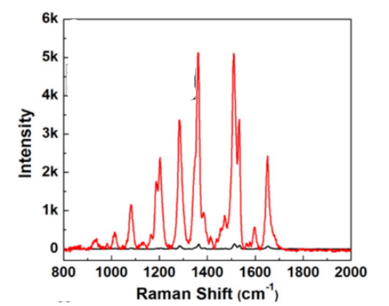

Figure 68:https://doi.org/10.1016/j.msec.2016.03.113

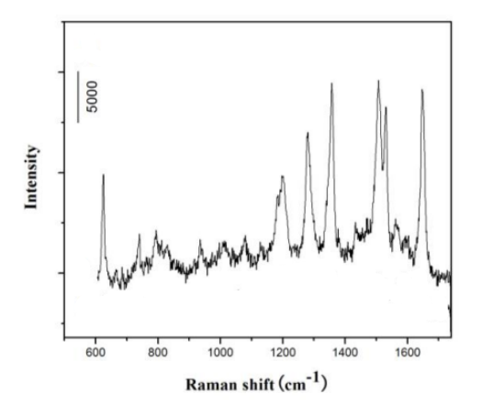

Figure 69:http://dx.doi.org/doi:10.1016/j.apsusc.2016.03.084

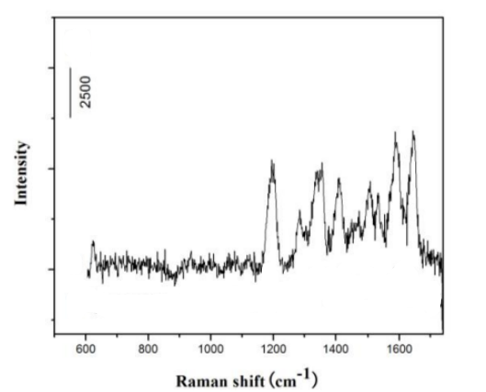

Figure 70:http://dx.doi.org/doi:10.1016/j.apsusc.2016.03.084

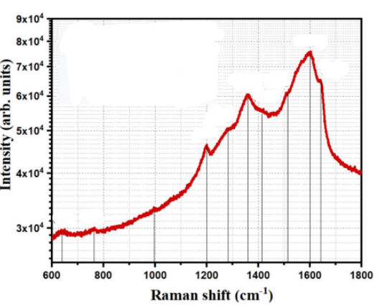

Figure 71:https://doi.org/10.1007/s11468-023-01965-z

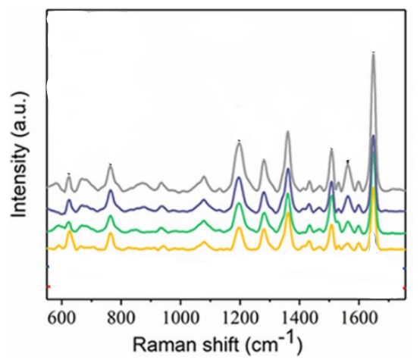

Figure 72:https://doi.org/10.1007/s11051-022-05590-5

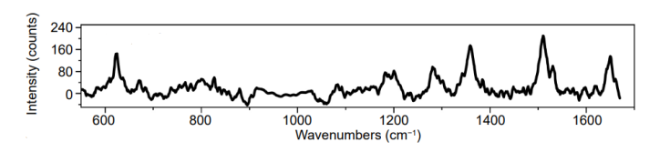

Figure 73:https://doi.org/10.29026/oea.2025.240309

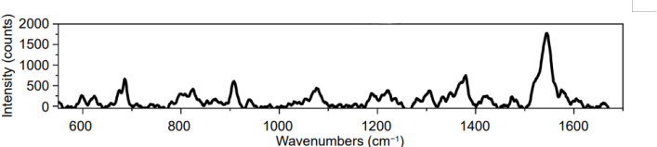

Figure 74:https://doi.org/10.29026/oea.2025.240309

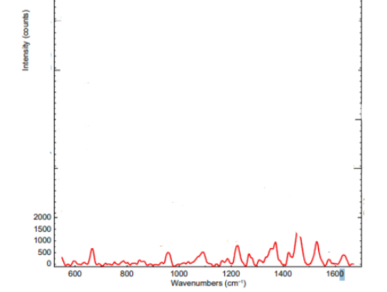

Figure 75:https://doi.org/10.29026/oea.2025.240309

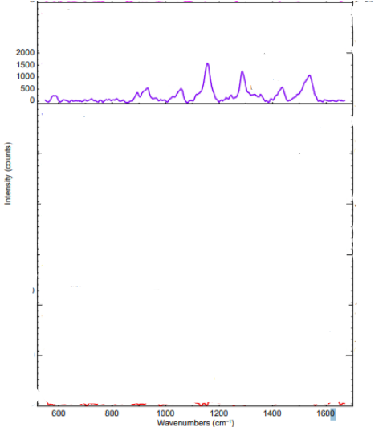

Figure 76:https://doi.org/10.29026/oea.2025.240309

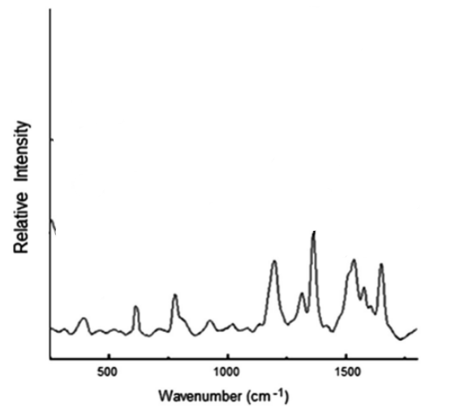

Figure 77:http://dx.doi.org/10.1063/1.4769780

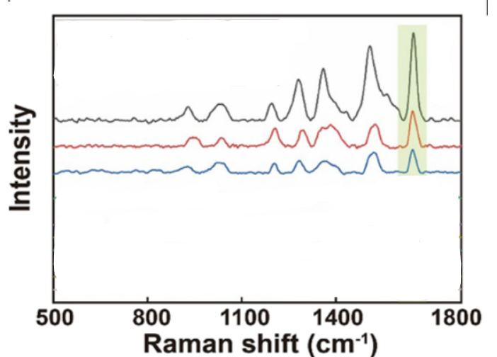

Figure 78:https://doi.org/10.1021/acsami.2c19354

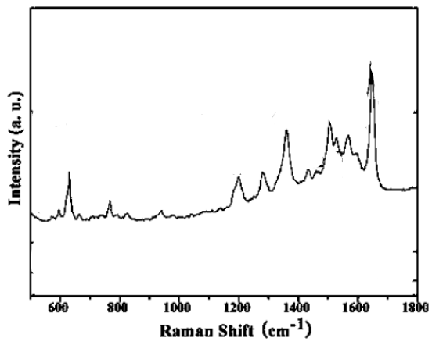

Figure 79:https://doi.org/10.1021/cg8004213

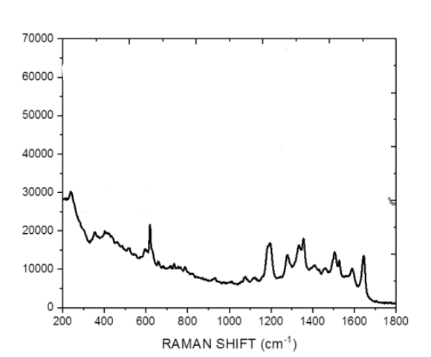

Figure 80:https://theses.hal.science/tel-02513402/

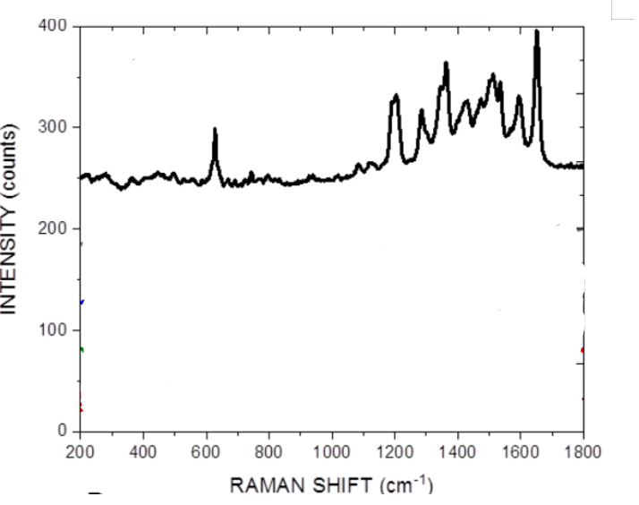

Figure 81:https://theses.hal.science/tel-02513402/

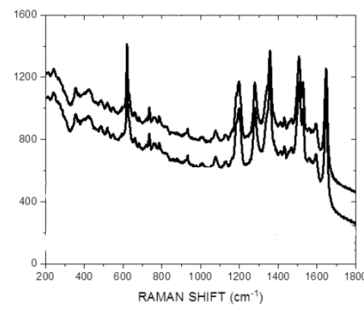

Figure 82:https://theses.hal.science/tel-02513402/

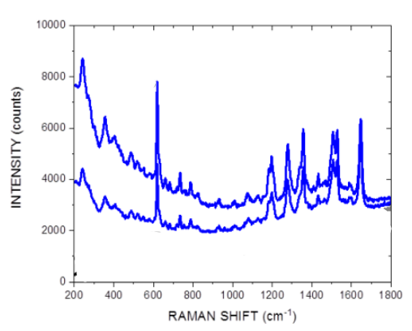

Figure 83:https://theses.hal.science/tel-02513402/

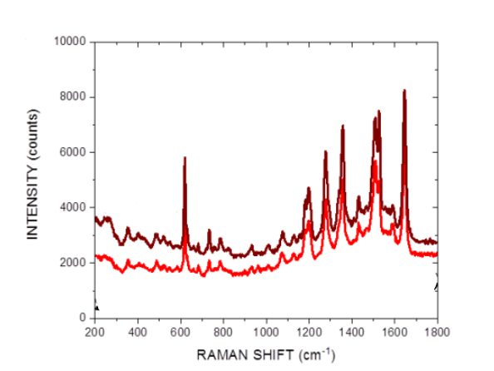

Figure 84:https://theses.hal.science/tel-02513402/

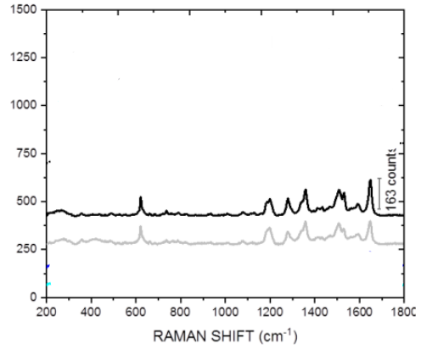

Figure 85:https://theses.hal.science/tel-02513402/

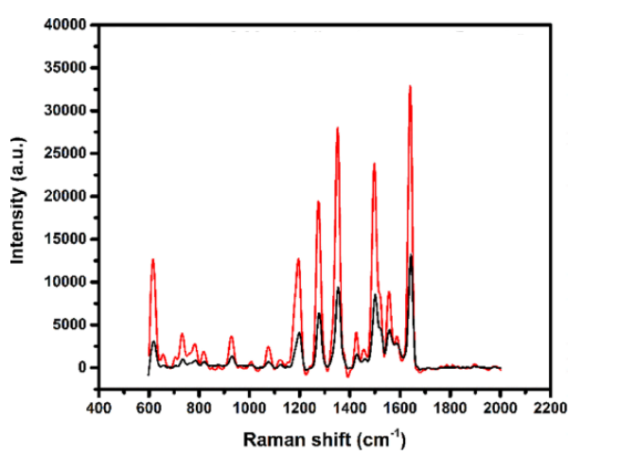

Figure 86:https://doi.org/10.1021/acs.jpcc.0c00552

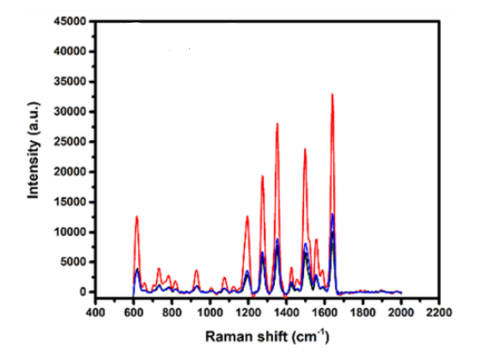

Figure 87:https://doi.org/10.1021/acs.jpcc.0c00552

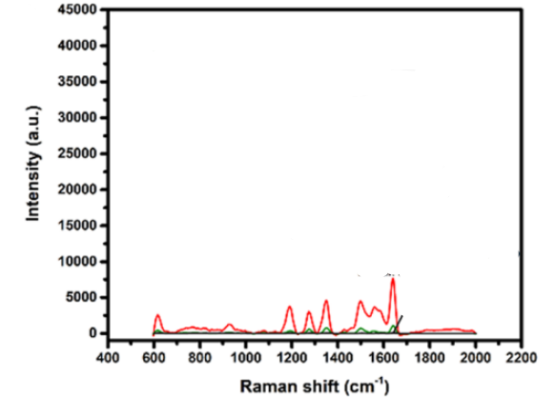

Figure 88:https://doi.org/10.1021/acs.jpcc.0c00552

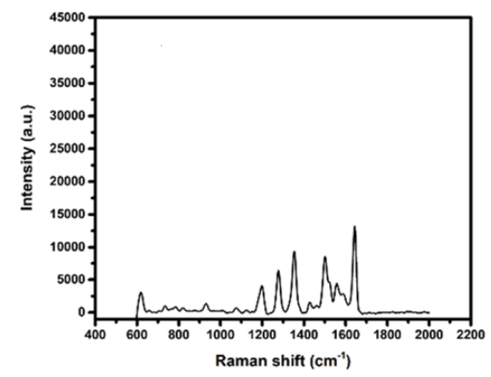

Figure 89:https://doi.org/10.1021/acs.jpcc.0c00552

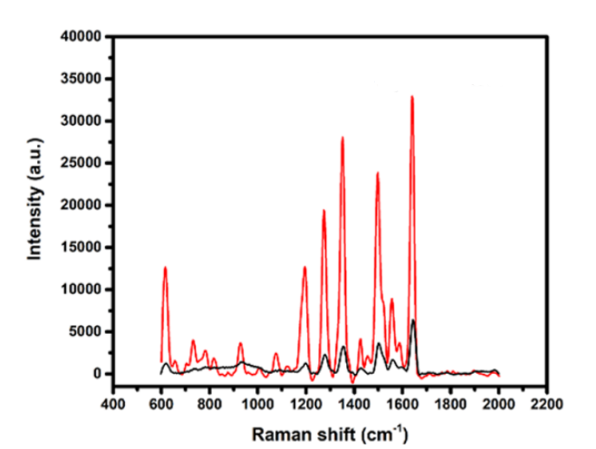

Figure 90:https://doi.org/10.1021/acs.jpcc.0c00552

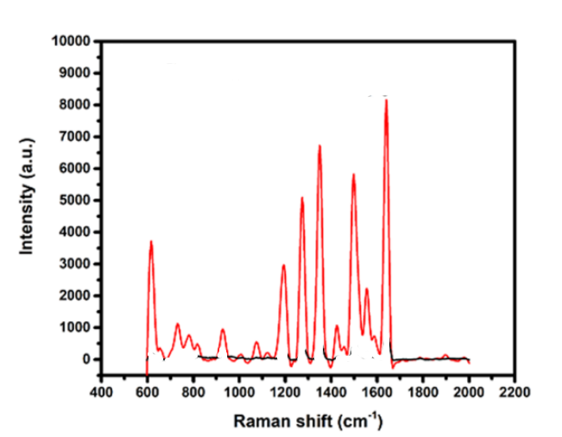

Figure 91:https://doi.org/10.1021/acs.jpcc.0c00552

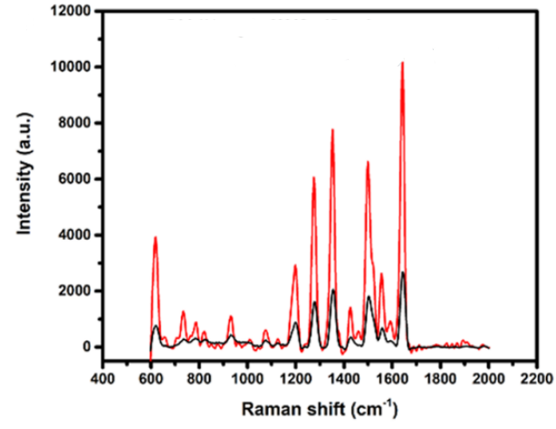

Figure 92:https://doi.org/10.1021/acs.jpcc.0c00552

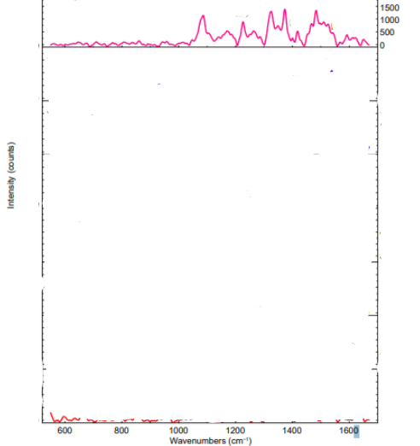

Figure 93:https://doi.org/10.29026/oea.2025.240309

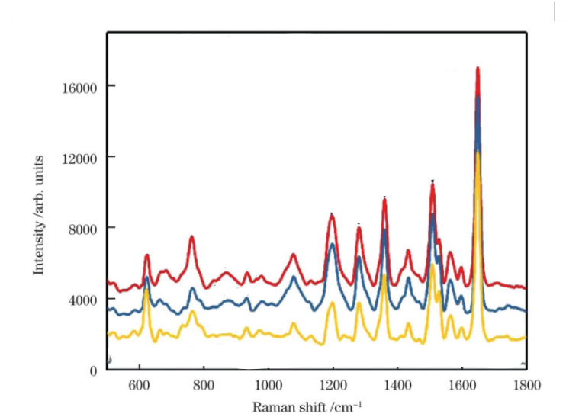

Figure 94:https://www.researching.cn/ArticlePdf/m00001/2024/51/16/1602406.pdf

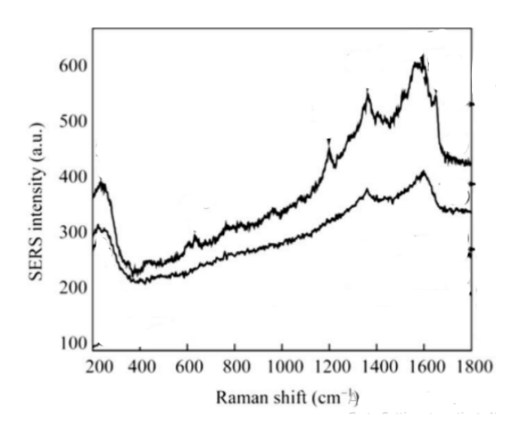

Figure 95:10.1021/bk-2018-1305.ch002

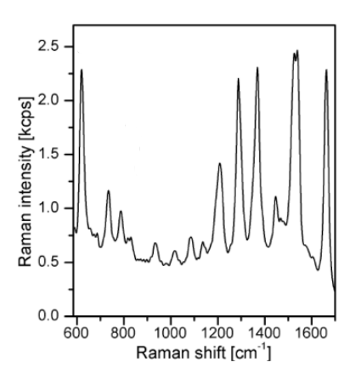

Figure 96:https://bibliotekanauki.pl/articles/1490450.pdf

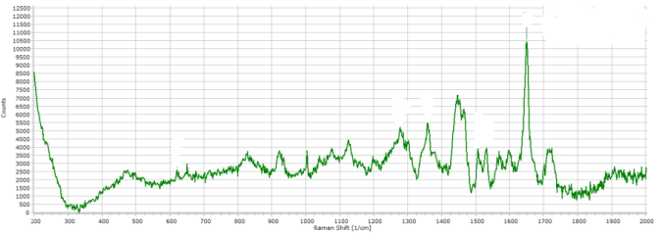

Figure 97:https://dspace.lib.ntua.gr/xmlui/bitstream/handle/123456789/54649/Thesis%20-%20Ellie%20Kousouli.pdf

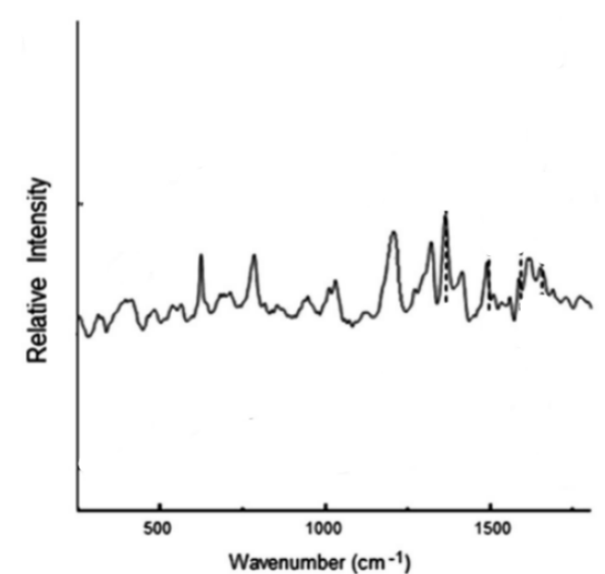

**Figure 98:**http://dx.doi.org/10.1063/1.4769780

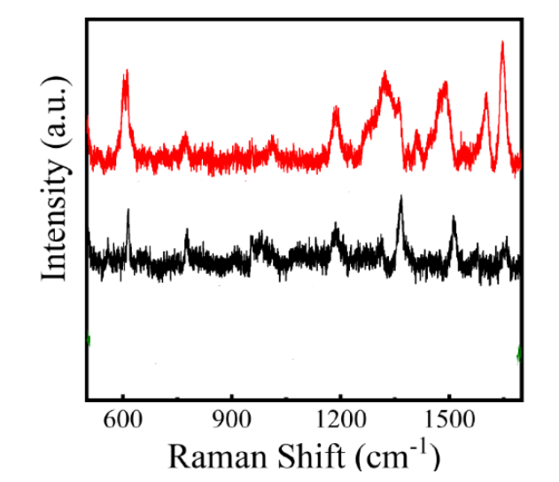

Figure 99:https://doi.org/10.3390/nano15130998

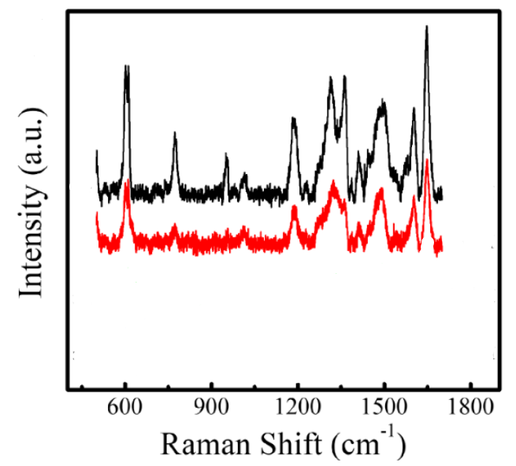

Figure 100:https://doi.org/10.3390/nano15130998